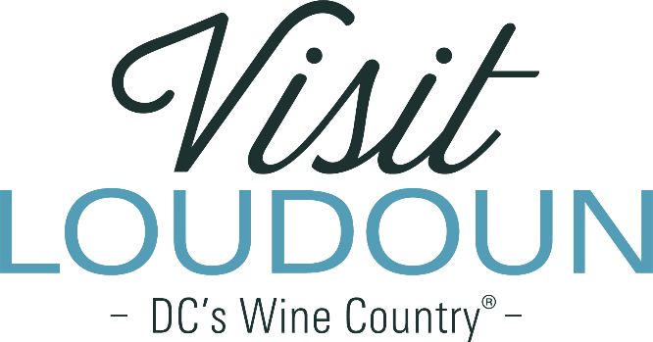

Request For Proposal

Signature Songwriter Event

Introduction, Background and General Information:

Background: Visit Loudoun is the only organization solely dedicated to maximizing brand awareness and driving visitor demand for Loudoun County, Va., located 25 miles from Washington, DC. This not-for-profit organization develops and implements programs that promote tourism and travel to Loudoun and its towns, to increase visitation and generate visitor spending.
Loudoun is unique in our diversity of product—our equestrian experiences; craft-beverage and restaurant scene; agriculture and historic attractions; and outdoor recreation assets—make us a very attractive destination to leisure and business travelers as well as those coming to Loudoun for sporting events, meetings, or weddings.

Loudoun’s tourism revenue topped just over $3 billion in 2021, making Loudoun the top generator of visitor revenue for the Commonwealth. In 2021, tourism supported 13,533 jobs and $751 million in salaries and wages. It generated $108.9 million in local taxes as well as $55 million in state taxes.

MISSION: To stimulate the sustainability and enhancement of Loudoun County’s economy and quality of life by advocating for smart destination development and marketing an exceptional experience to travel consumers worldwide.

VISION: To be a “must visit” destination supported by a community that recognizes the economic and quality of life benefits that come from sharing our home with visitors. Loudoun County will be the preferred east coast destination for lovers of artisanal, epicurean, and culturally rich experiences.

Visit Loudoun’s Strategic Plan:

Visit Loudoun’s FY23-FY25 Strategic Plan identifies strategies to leverage music and the arts to drive demand as well as enhance the visitor experience. 40% of visitors surveyed during the Strategic Plan process stated that they enjoyed local music as a part of their visitor experience over the past three years, while 56% stated that they view local music as integral to their next trip. This demonstrates continued demand to grow Loudoun as a destination for local music.

One of Visit Loudoun’s five pillars of its strategic plan is to support music and the arts. While there are strategies outlined in the Strategic Plan, here are three key areas of focus:
- Facilitate and support Loudoun County as a destination for music and the arts
- Integrate music and arts into the greater tourism assets and existing events
- Foster and support the local arts scene

Request for Proposal:
Visit Loudoun is seeking proposals from qualified festival/event planners with expertise in creating multi-day events focused on songwriters. The event will create a unique sense of place; build on the characteristics of Loudoun County (DC’s Wine Country); incorporate live performances in multiple venues; and be inclusive of regional and national acts along with local Loudoun area musicians of various genres. The event will increase awareness of Loudoun as a music destination, drive overnight stays and generate economic impact for the community.

Visit Loudoun has received $75,000 in ARPA funding for the development of the event and will be listed as the presenting sponsor. The event must take place by May 31, 2024 and all allocated funds used by that date.

Process:
- March 27, 2023: Request for Proposal issued by Visit Loudoun
- March 27, 2023: Request for Proposal on VisitLoudoun.org and Biz.Loudoun.gov
- April 12, 2023, written questions submitted by 5:00 pm EST to Marketing@VisitLoudoun.org
- April 13, 2023 at 3:00: Virtual information session for prospective bidders https://meet.goto.com/348195597
- April 28, 2023: Proposals submitted by 5:00 pm EST to Marketing@VisitLoudoun.org
- May 11, 2023: Virtual proposal presentation by finalists to selection committee
- May 19, 2023: Contract Awarded

Proposal Requirements:
Interested parties should provide a copy of their proposal, including the information outlined below. Submissions may be supplemented with samples that are similar or relevant to this project.

Please include the following:
- Name and location of organization, including information that pertains to diversity, equity, inclusion, and accessibility policies.
- Professional qualifications and experience.
- Scope of work, including outline of work plan and budget inclusive of all related expenses.
- Plan to activate and leverage additional resources for operating budget, beyond the Visit Loudoun sponsorship.
- Proposed title and timing of the event.
- Describe how the event will feature songwriters and the songwriting process.
- Describe the plan to involve and feature Loudoun area artists along with regional and national artists.
- Describe the types of venues envisioned and the associated plan to work with them.
- Marketing plan outlining your target audience and how you will reach that audience.
- Production plan to deliver on your vision of the event.

Selection Criteria
Proposals received in response to this RFP will be objectively reviewed by a steering committee comprised of Visit Loudoun board members, Loudoun area artists and producers. Selection will be based on the following criteria:
- Ability to deliver an event that complements the “DC’s Wine Country” brand.
- Approach to include Loudoun area artists and venues.
- The organization’s ability to perform the scope of work based on prior experience.
- References provided by individuals involved in past engagements.
- The organization’s demonstrated ability to complete the project on schedule.
- Budget, including sponsorship plan and the ability to bring the event to fruition by May 30, 2024.

A firm will be selected based on the needs of Visit Loudoun and Loudoun Economic Development which reserve the right to negotiate and/or reject all submissions if necessary.

All questions regarding this RFP may be addressed to Beth Erickson at 703-771-4964 or Erickson@VisitLoudoun.org. Additional information about Visit Loudoun can be found on the resources tab at http://www.visitloudoun.org/industry, including our FY23-FY25 Strategic Plan, marketing plan and DC’s Wine Country brand study.

